**Lab 12**

**VPC Peering Lab – 2 of 3**

In Ohio region, we need to create VPC.

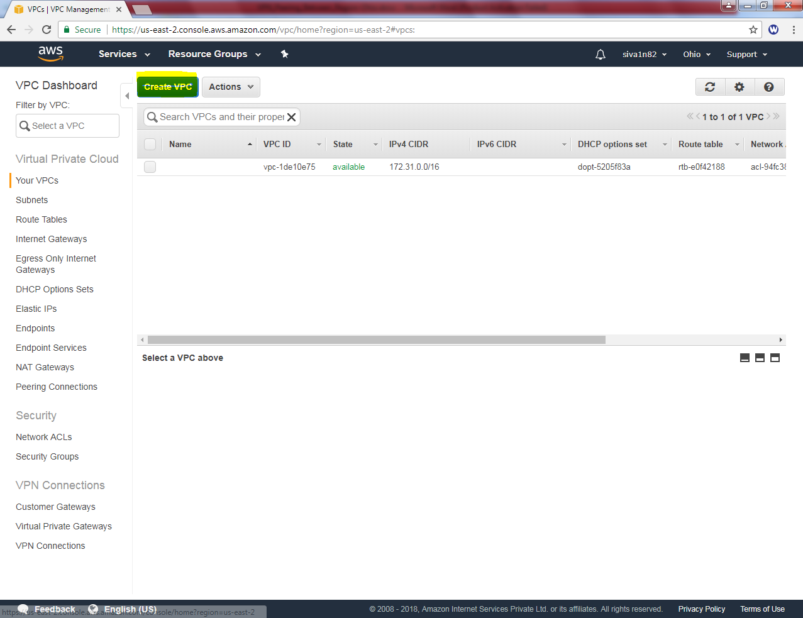

Click “Create VPC”.

While creating VPC, type name tag as “Sansbound VPC Ohio”and IPV4 CIDR Block as 192.168.0.0/16 subnet.

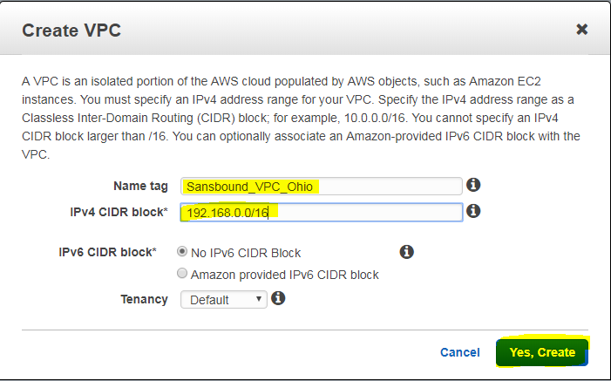

Then click “Yes, create”.

Then we need to create subnet for “Sansbound VPC Ohio” VPC.

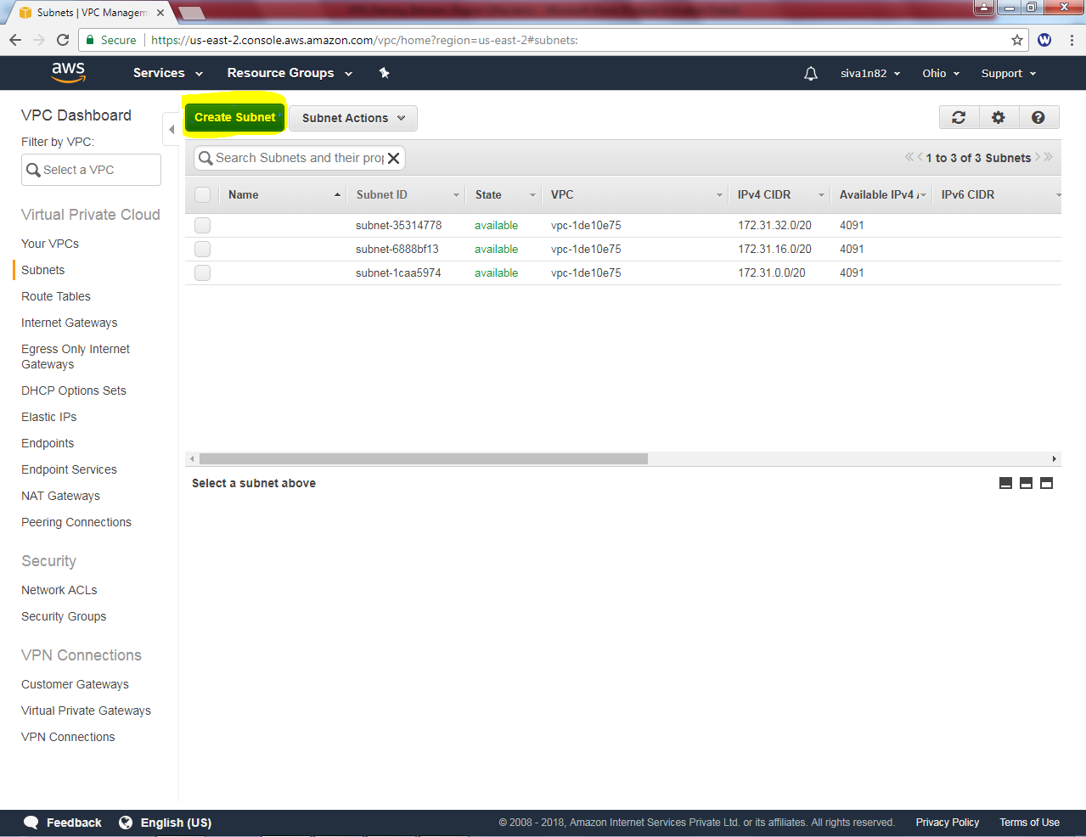

Click “Create Subnet”.

While creating Subnet, name tag as “Sansbound_Ohio_Public_Subnet”, VPC as Sansbound_VPC_Ohio, Availability Zone – 2b (optional) and IPV4 CIDR block as “192.168.2.0/24”subnet.

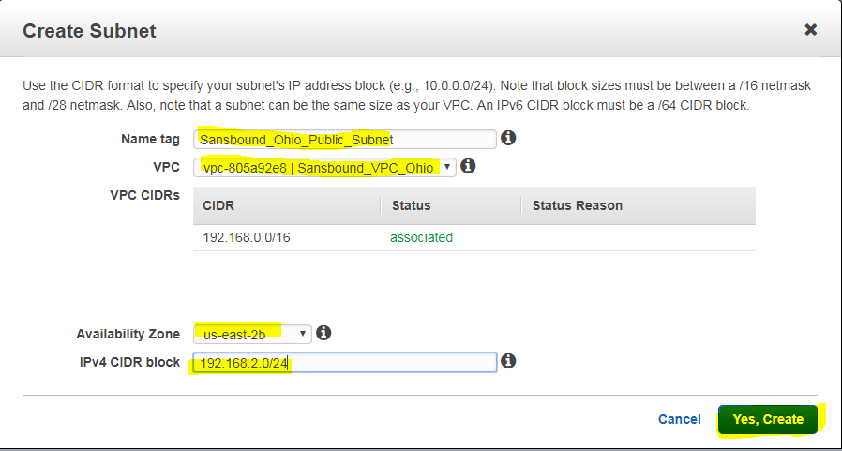

Then click “Yes, create”.

We have required to create an internet gateway.

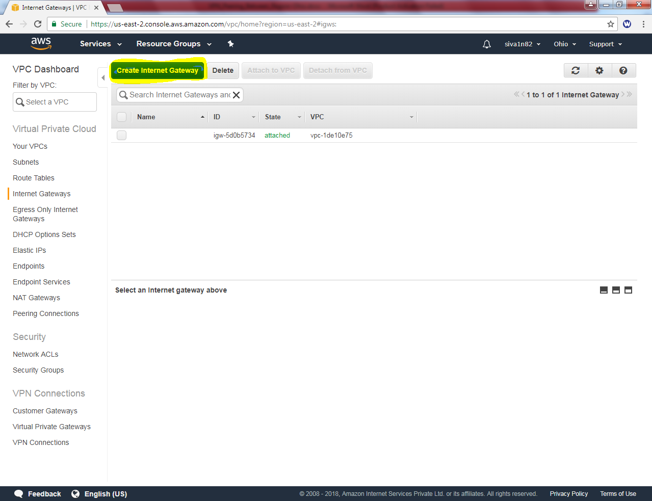

Click “Create Internet Gateway”

While creating Internet Gateway, name tag as “Sansbound_IGW_Ohio”.

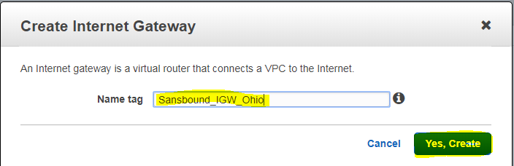

Click “Yes , create”.

Now internet gateway is in detached mode. We need to attach to Sansbound_VPC_Ohio VPC.

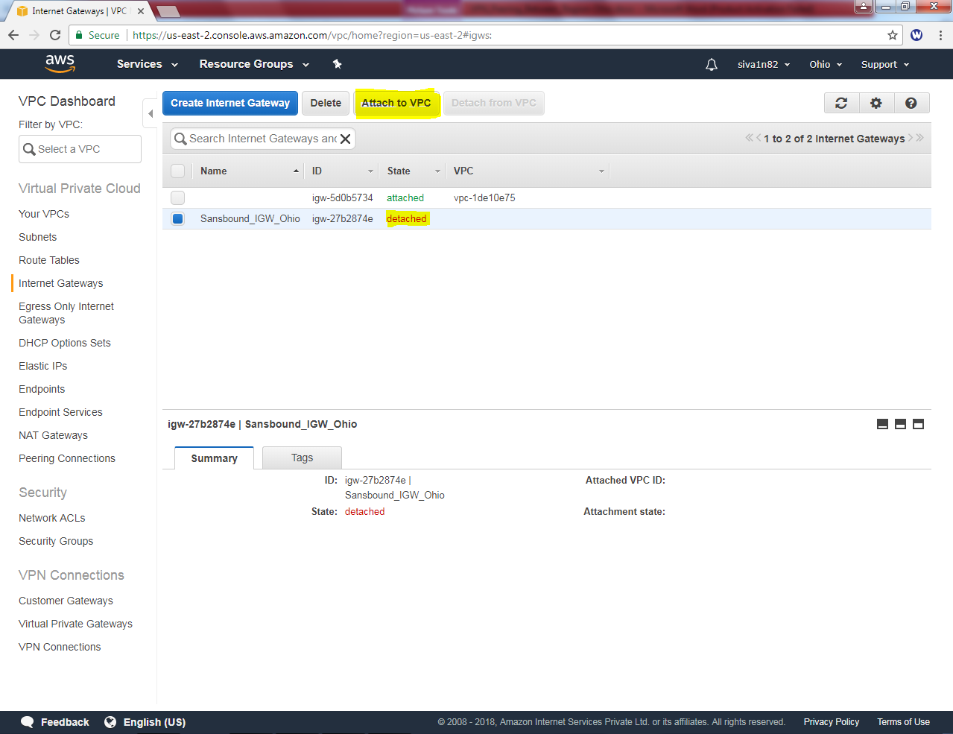

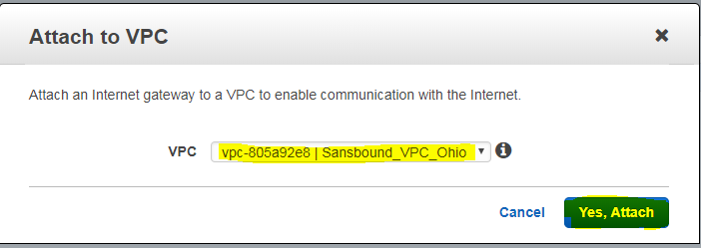

Then click “Yes attach”.

Type the route table value as sansbound_ohio_public

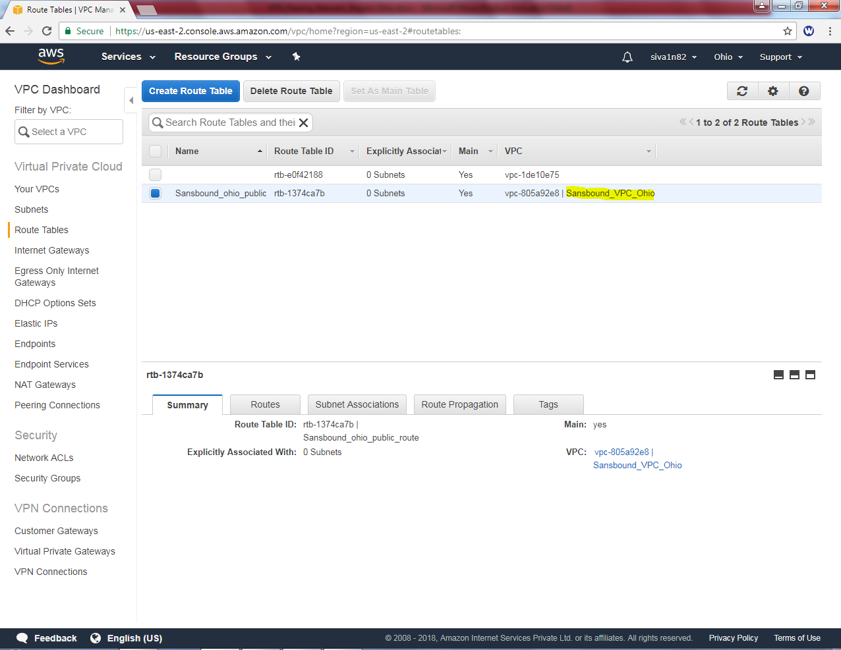

In Route table, route option click **“Edit”**.

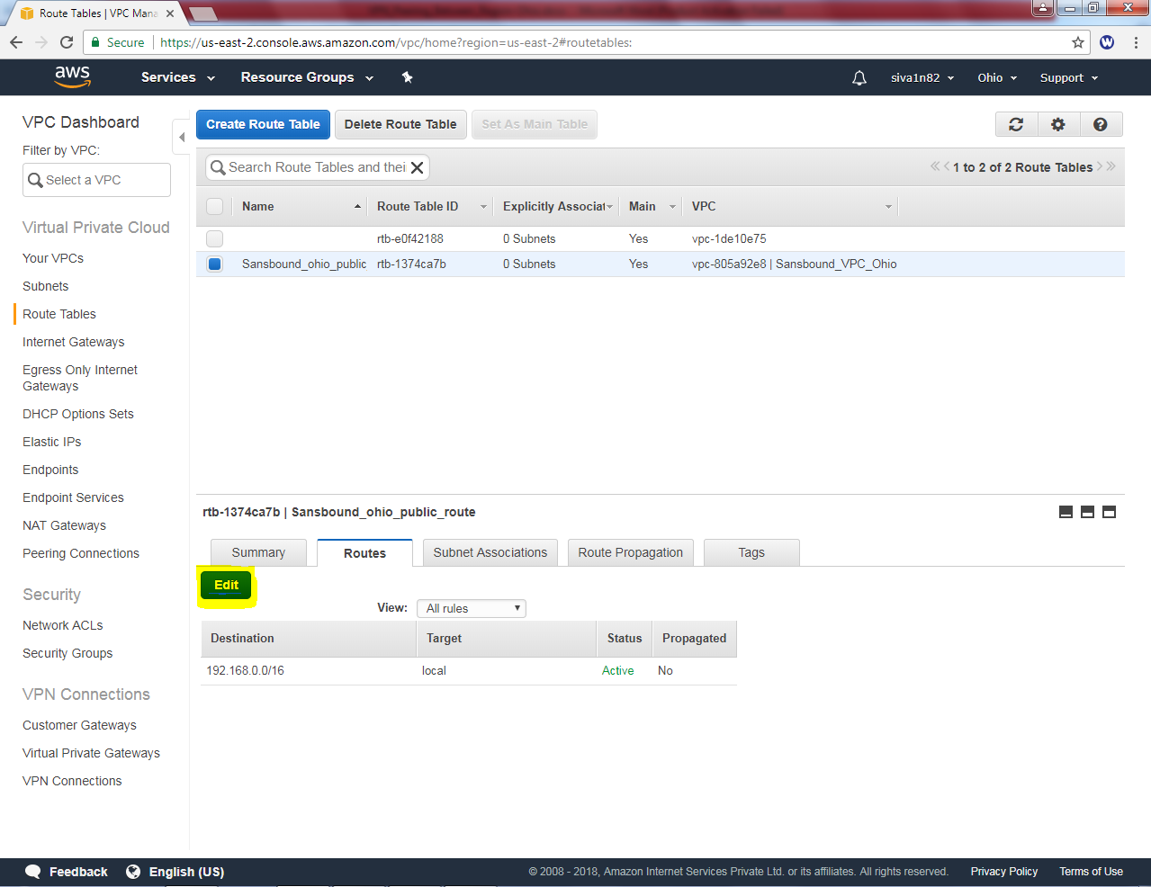

Click “Add another route”

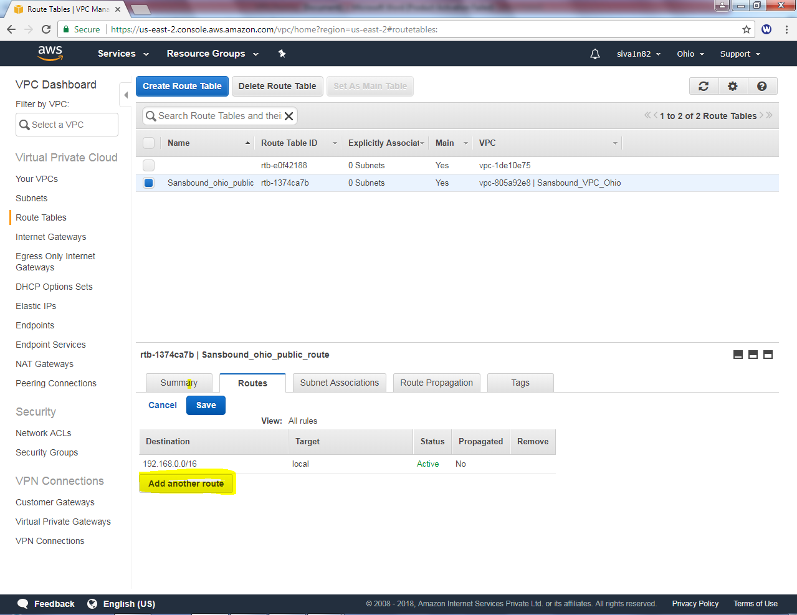

Type default route 0.0.0.0/0 and select igw-* in target.

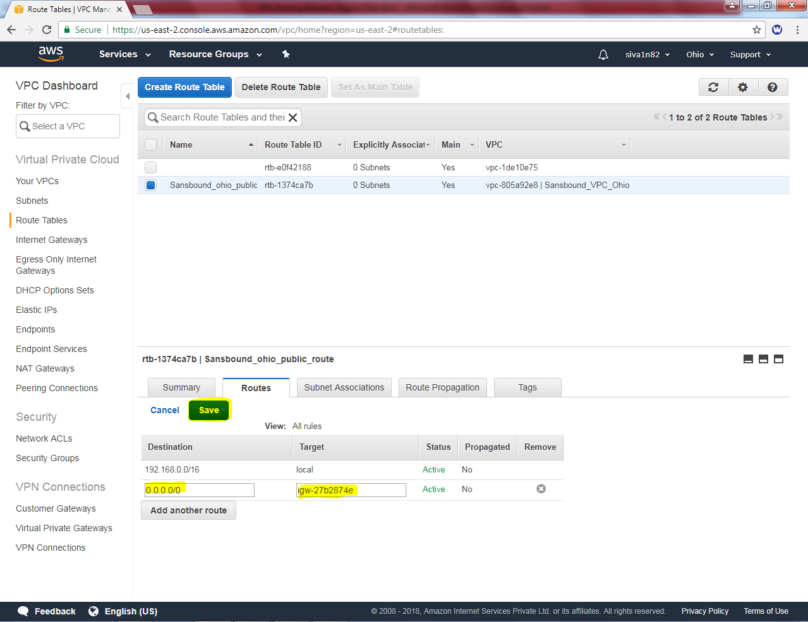

Then click “save”.

In Subnet Associations, click “Edit” option.

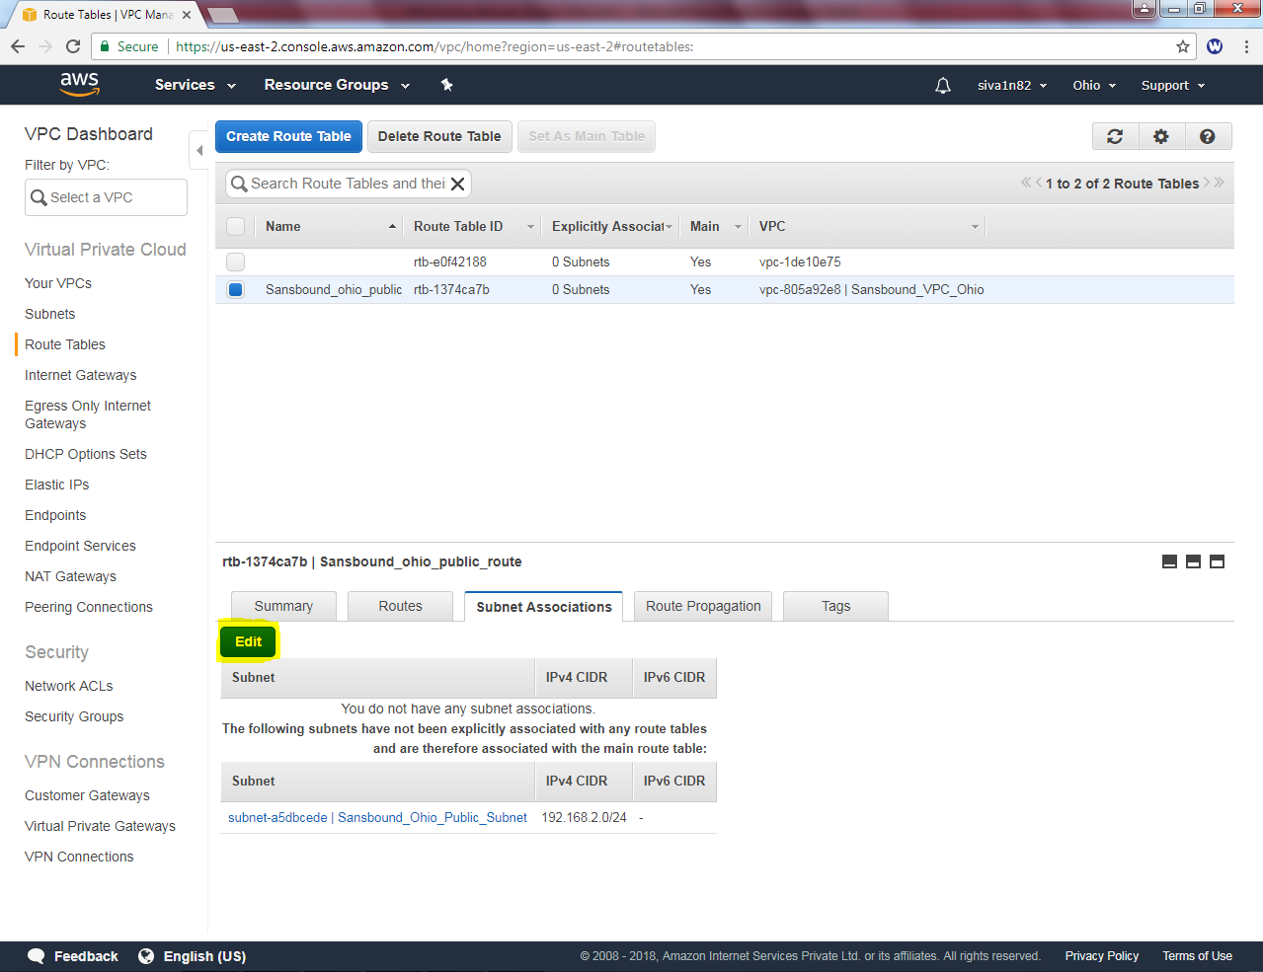

In Subnet association edit option, select the check box of Sandbound_Ohio_Public_Subnet.

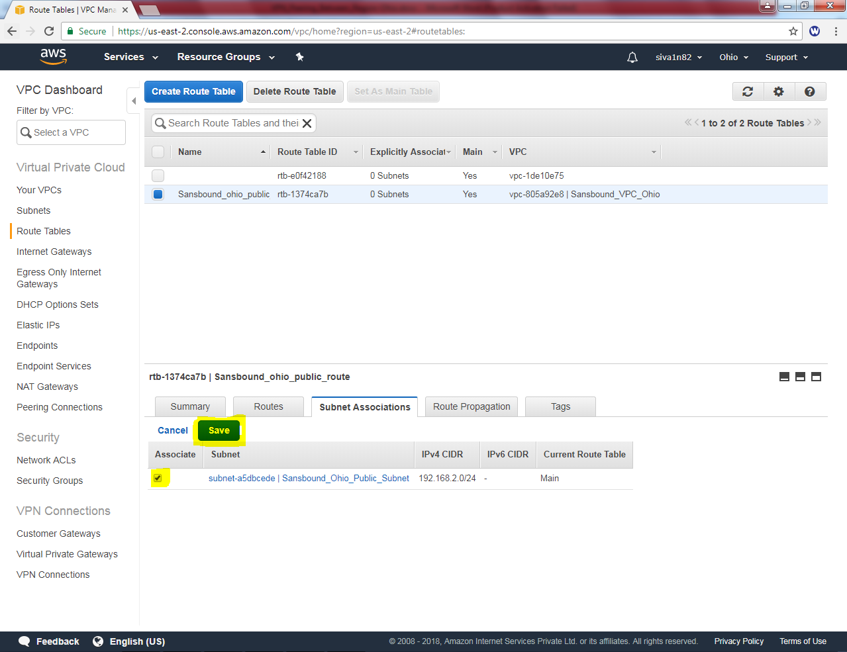

Then click “Save”.

Now we need to create an instance in Ohio Region.

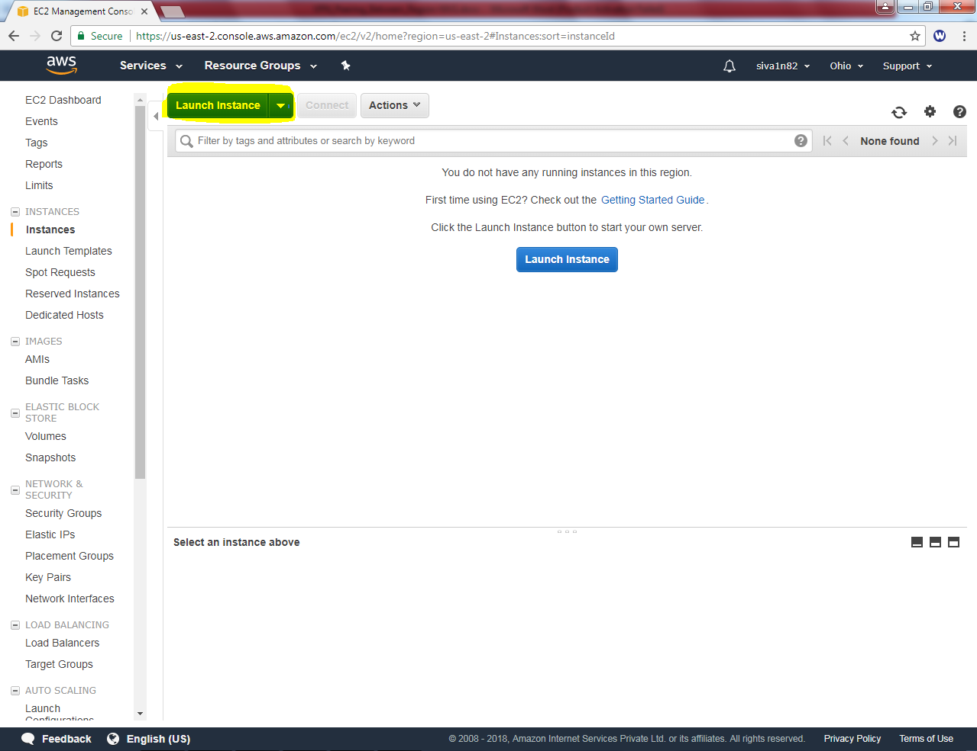

Select Microsoft Windows Server 2016 base

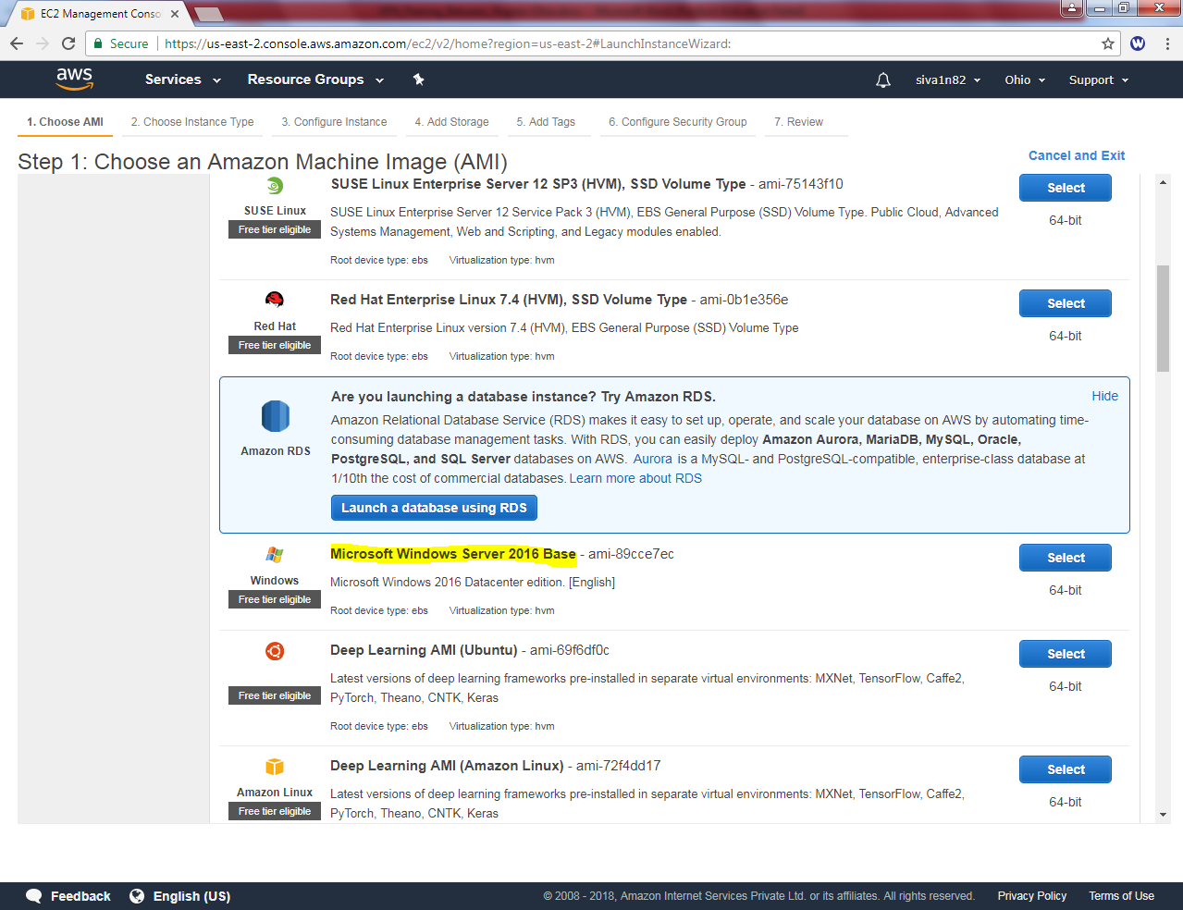

Select “t2.micro”.

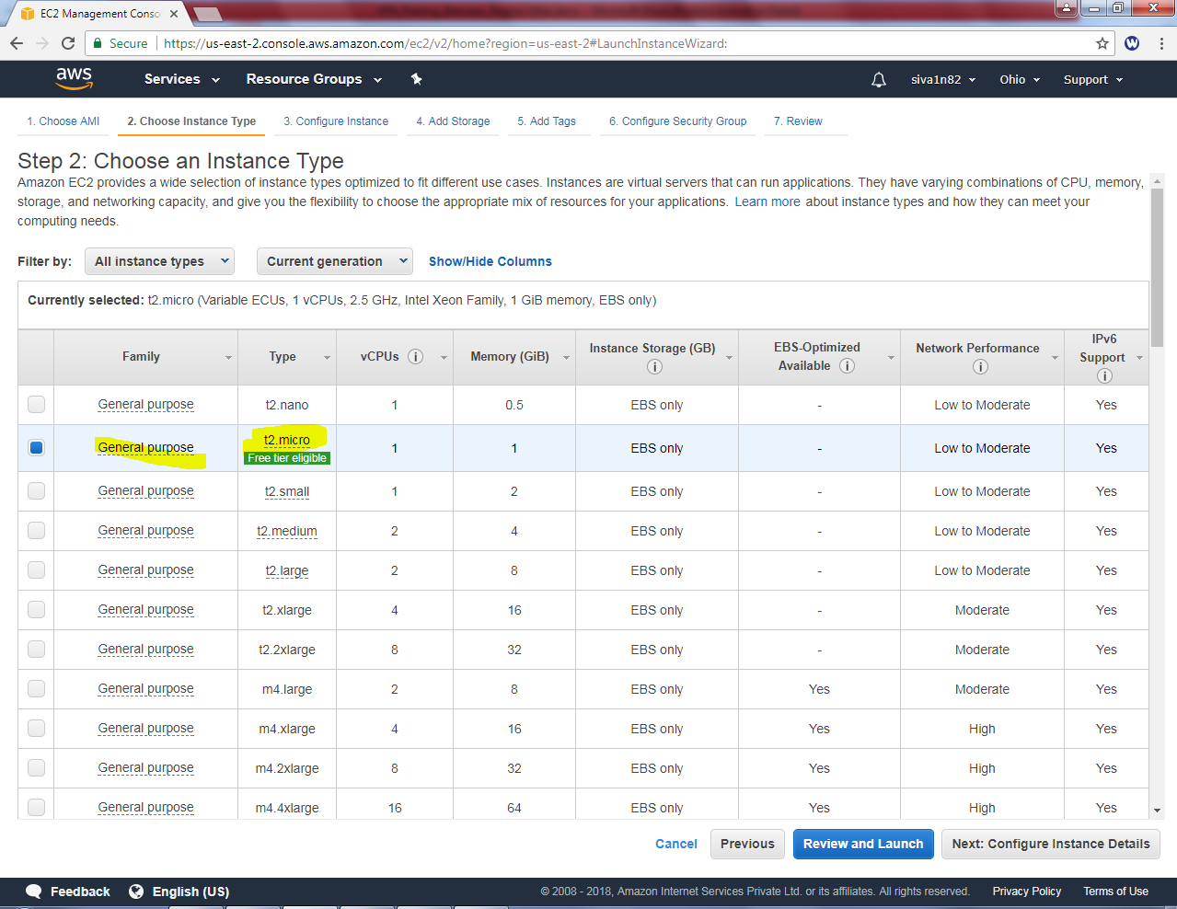

Click “Next”.

In Network, select sansbound_vpc_ohio

Subnet, select sansbound_ohio_public_subnet

Auto assign Public IP: Enable

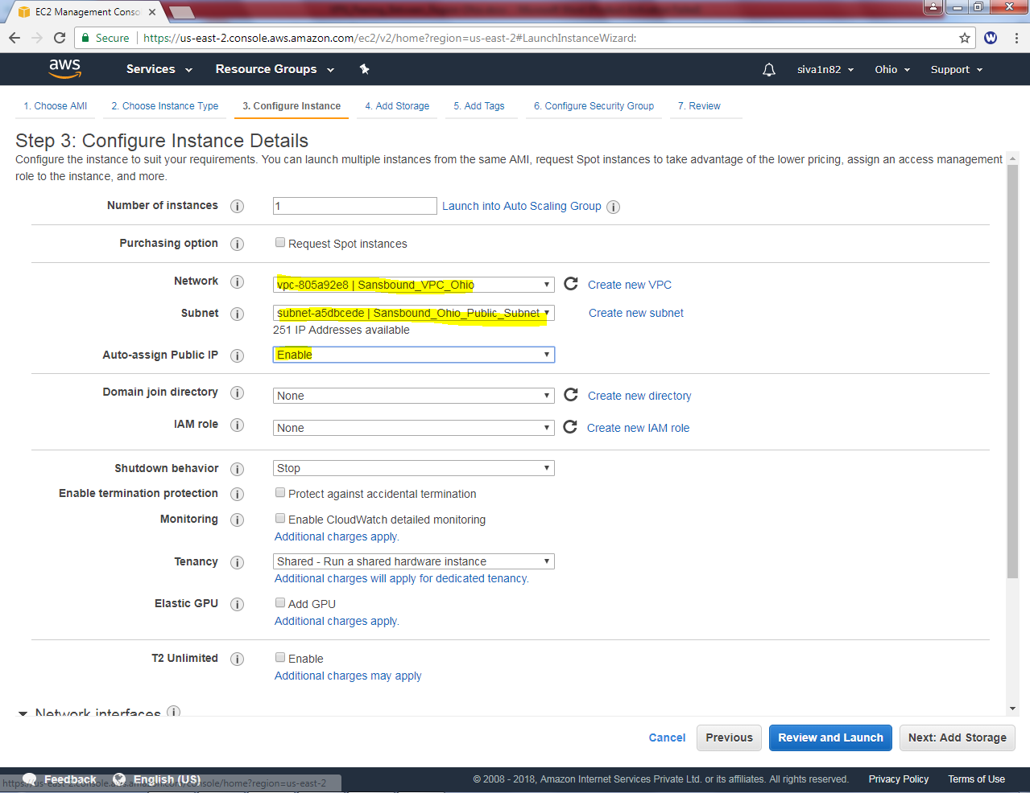

Click “Next”.

Leave default settings and click “Next”.

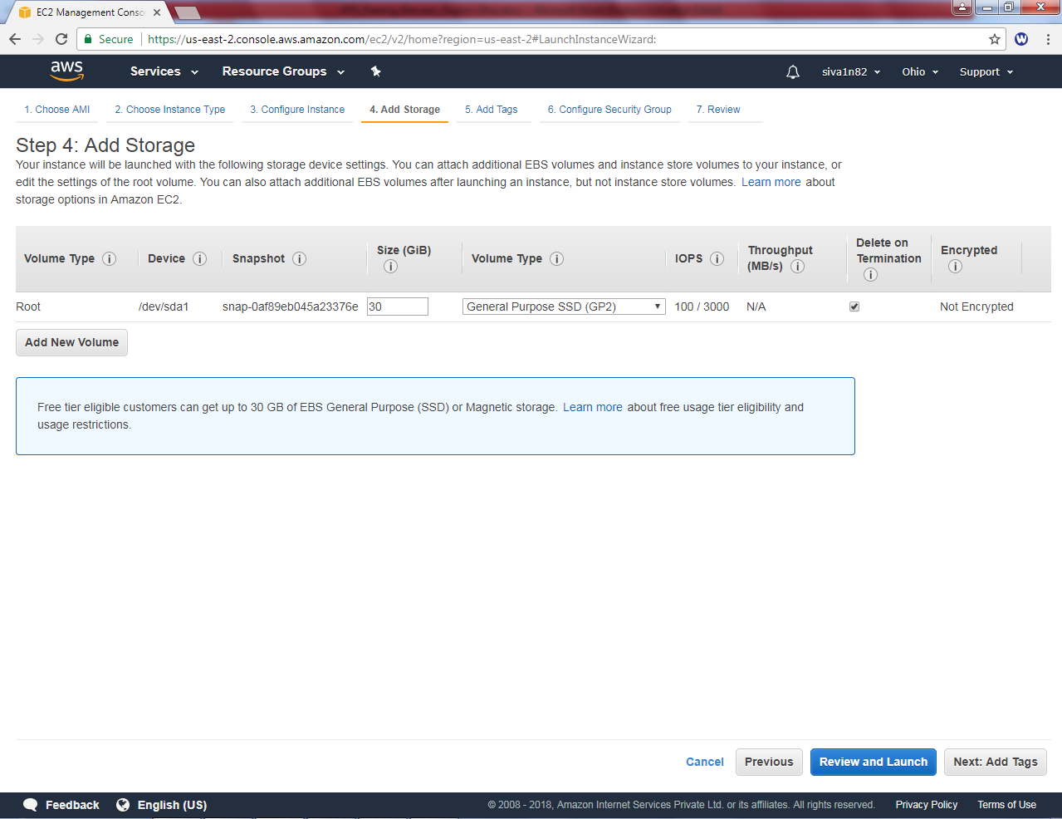

Type key as name and value as ohio public instance and click “Next”.

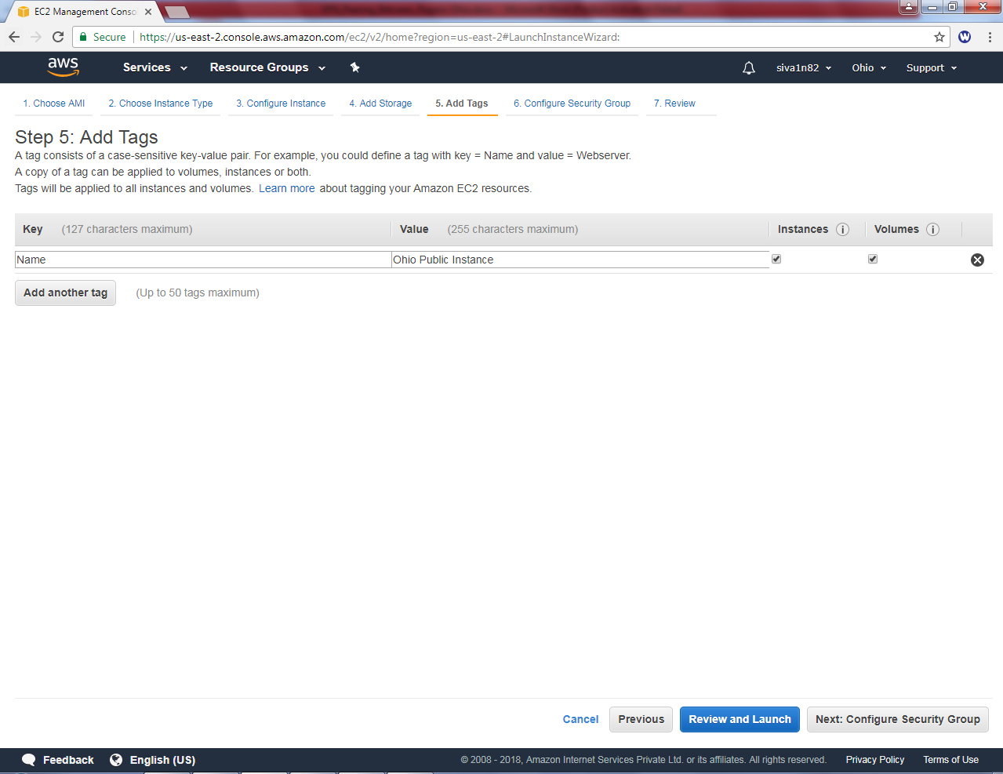

Create a new security group and permit RDP port 3389.

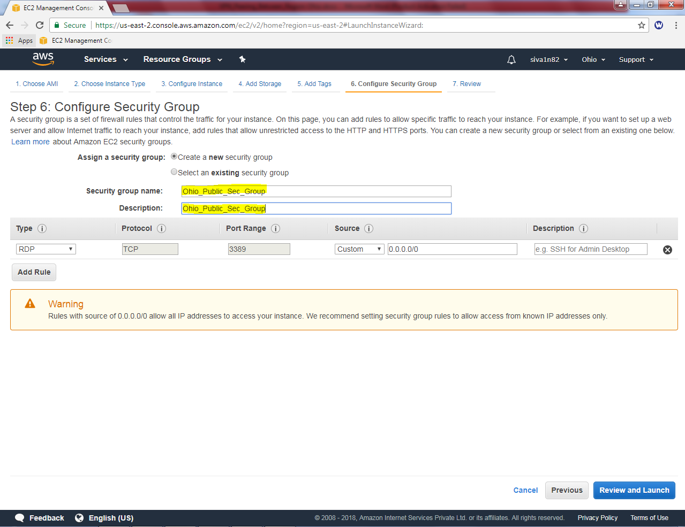

Click “Launch”.

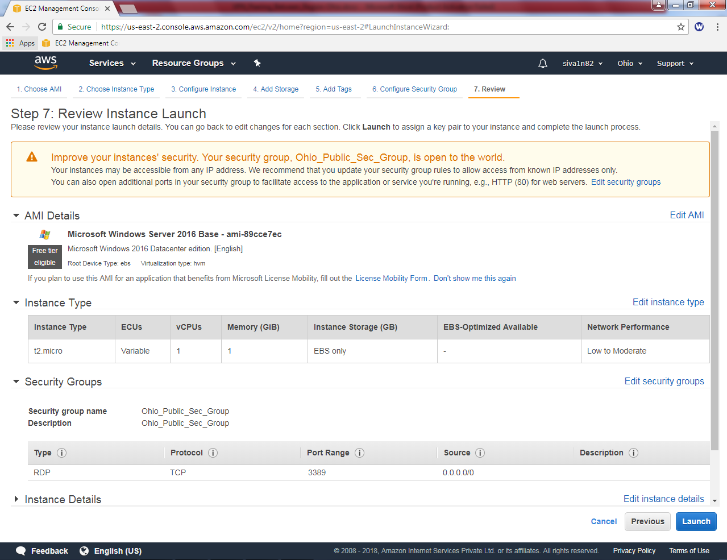

If you have already key pair select and launch the instance.

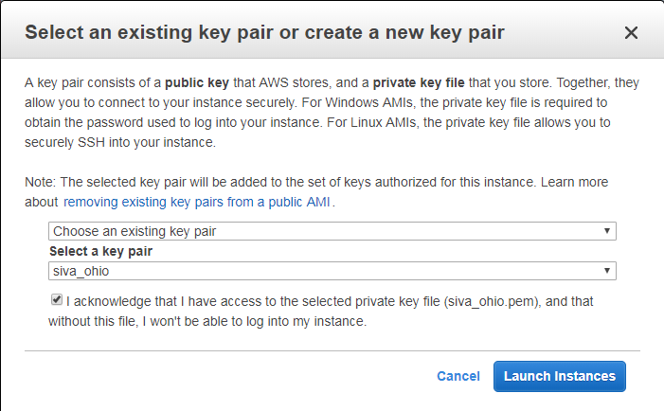

Click “Launch instances”.